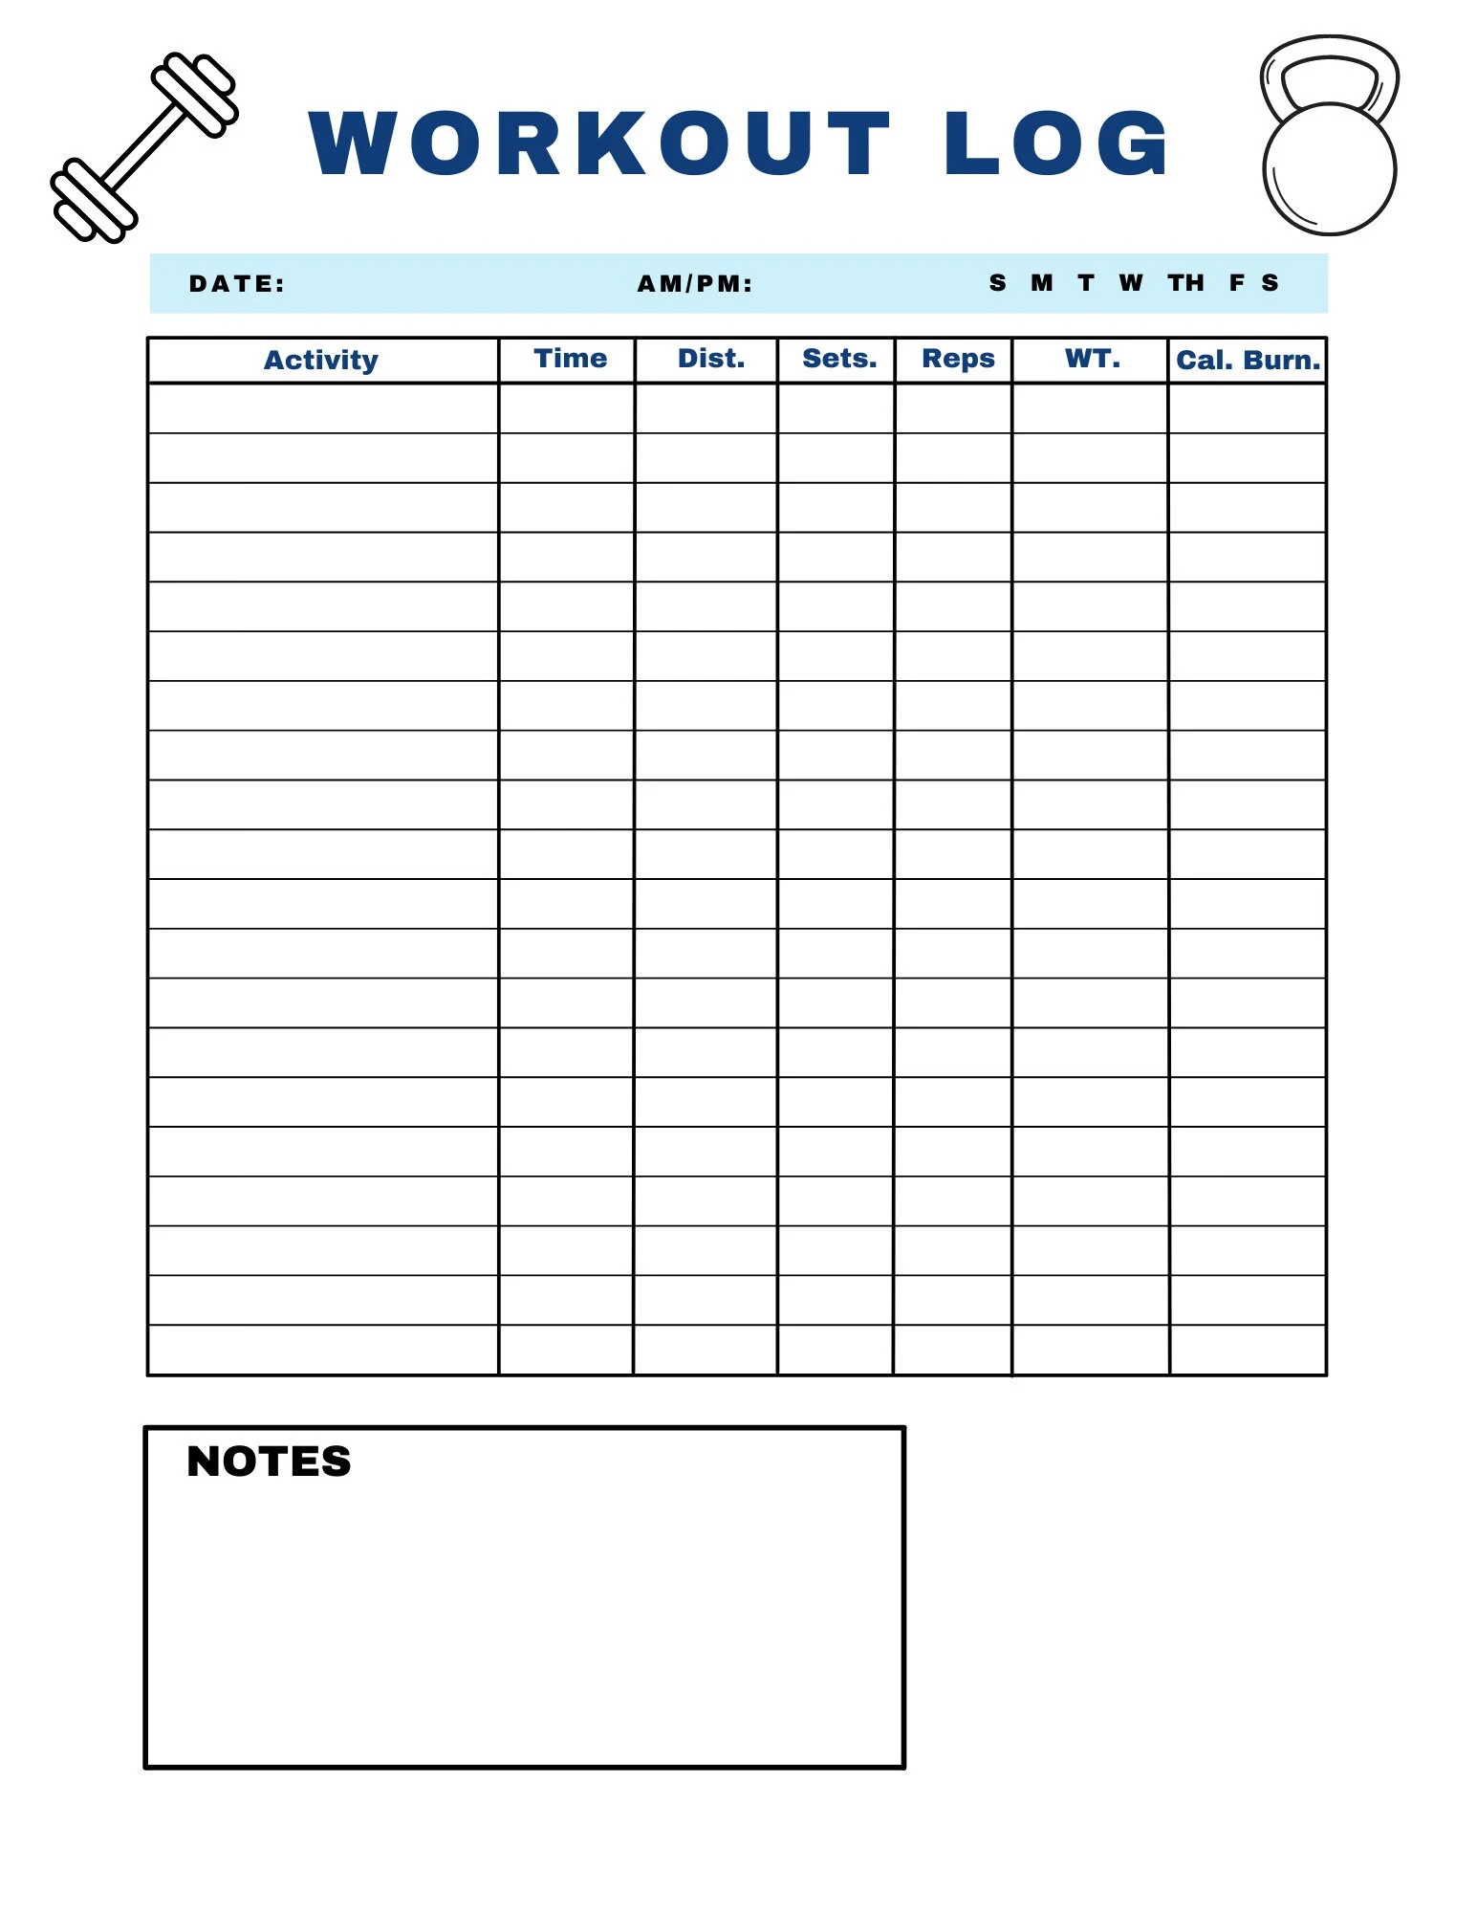

\*If possible, sync a wearable fitness device with the MyFitnessPal app to track calorie burns also.